MY AWS IAM LAB LOG
Creating a Least-Privilege IAM User
How I created the IAM user "Rahul" with only S3 access, tested it, and cleaned it up
Date: 24 September 2026 Service: IAM

Quick Overview
This session was about practicing least-privilege access in IAM. I created a new user named Abhishek, gave them console access with a custom password, and attached only the AmazonS3FullAccess policy — nothing else. I then logged in as that user in a separate browser session to prove S3 worked and EC2 did not, and finally deleted the user once the test was complete.

Configuration at a Glance
Setting | Value I used
User name | Rahul
Console access | Enabled, custom password
Force password reset | No
Permissions method | Attach policies directly
Policy attached | AmazonS3FullAccess (AWS managed)
Tags | None
S3 access test | Loaded S3 console with no errors
EC2 access test | Access denied on nearly every panel
Cleanup | User Rahul deleted after testing

Step 1: Specifying the New IAM User's Details
I opened IAM > IAM users > Create user and named the new user Rahul. I kept "Provide user access to the AWS Management Console" checked so this user could log in through the browser, not just via API keys, and chose Custom password instead of an autogenerated one, typing a password that met the 8-character, mixed-character-type requirement. I left "Users must create a new password at next sign-in" unchecked, since this was a quick test account rather than one I was handing to someone else.
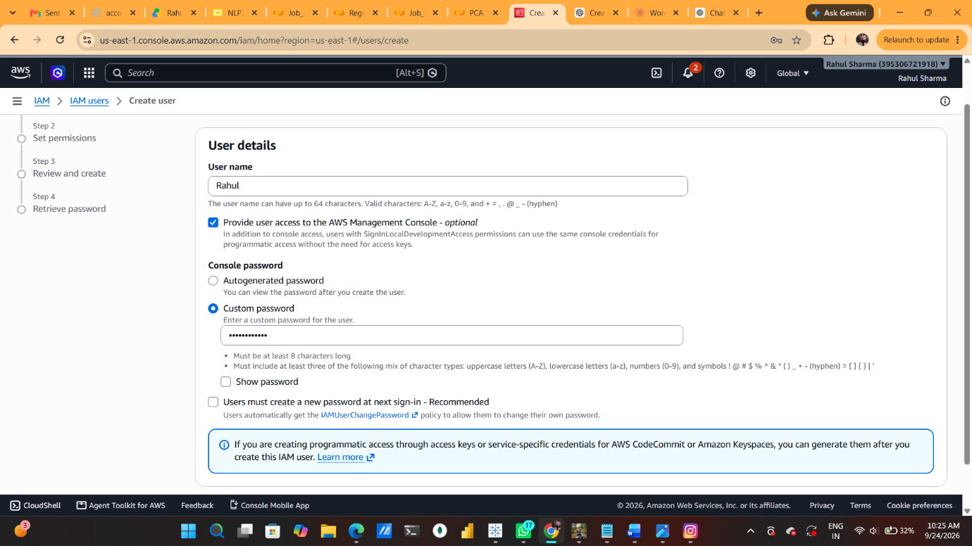

Step 2: Choosing How to Set Permissions
On the Set permissions step, AWS offered three ways to grant access: Add user to group, Copy permissions from an existing user, or Attach policies directly. Even though AWS calls groups the best practice for managing permissions by job function, I selected Attach policies directly since this was a single, one-off user and I only needed one specific policy.
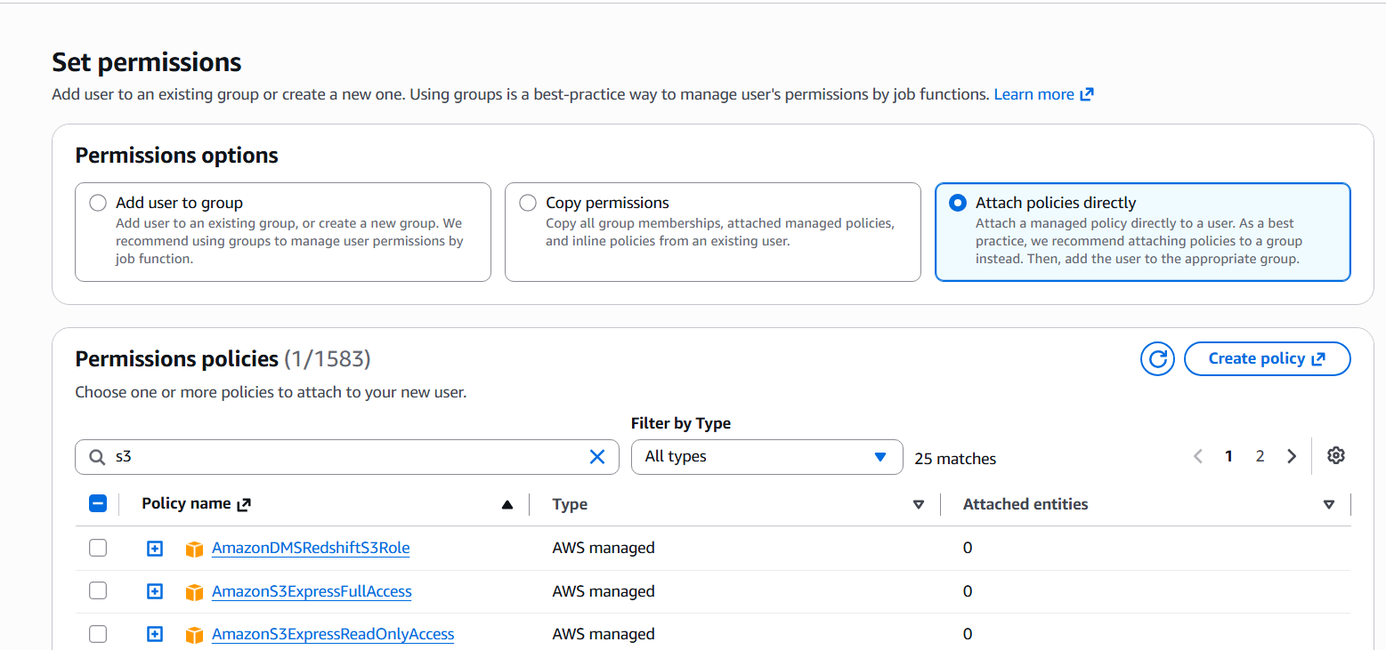

Step 3: Selecting the AmazonS3FullAccess Policy
From the long list of 1,583 AWS managed policies, I searched down to the S3-related ones and ticked AmazonS3FullAccess. This grants full control over S3 buckets and objects, but nothing else, which meant the user could not touch other services like EC2 unless something else granted that permission.
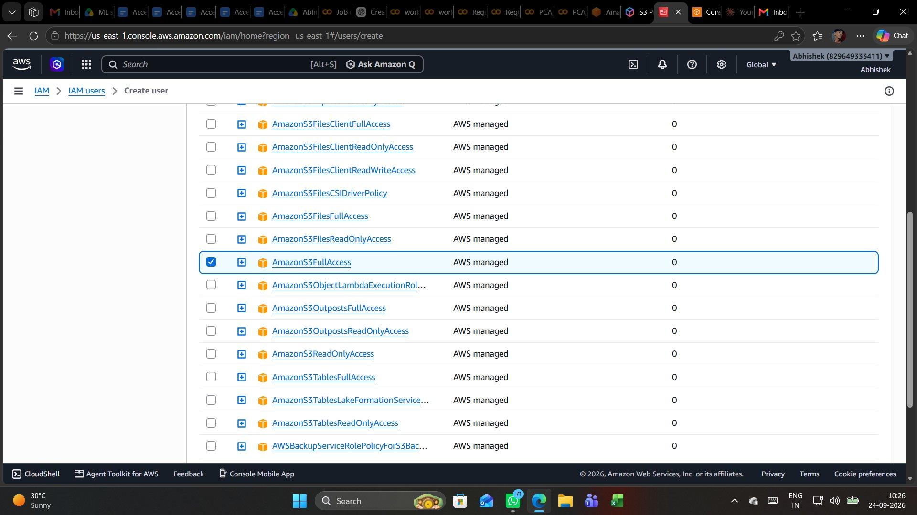

Step 4: Reviewing Everything Before Creation
The Review and create step summarized my choices: user name Rahul, a custom console password, no forced password reset, and AmazonS3FullAccess attached as an AWS managed policy. No tags were added. This was my last chance to change anything before AWS actually created the user, and everything matched what I intended.
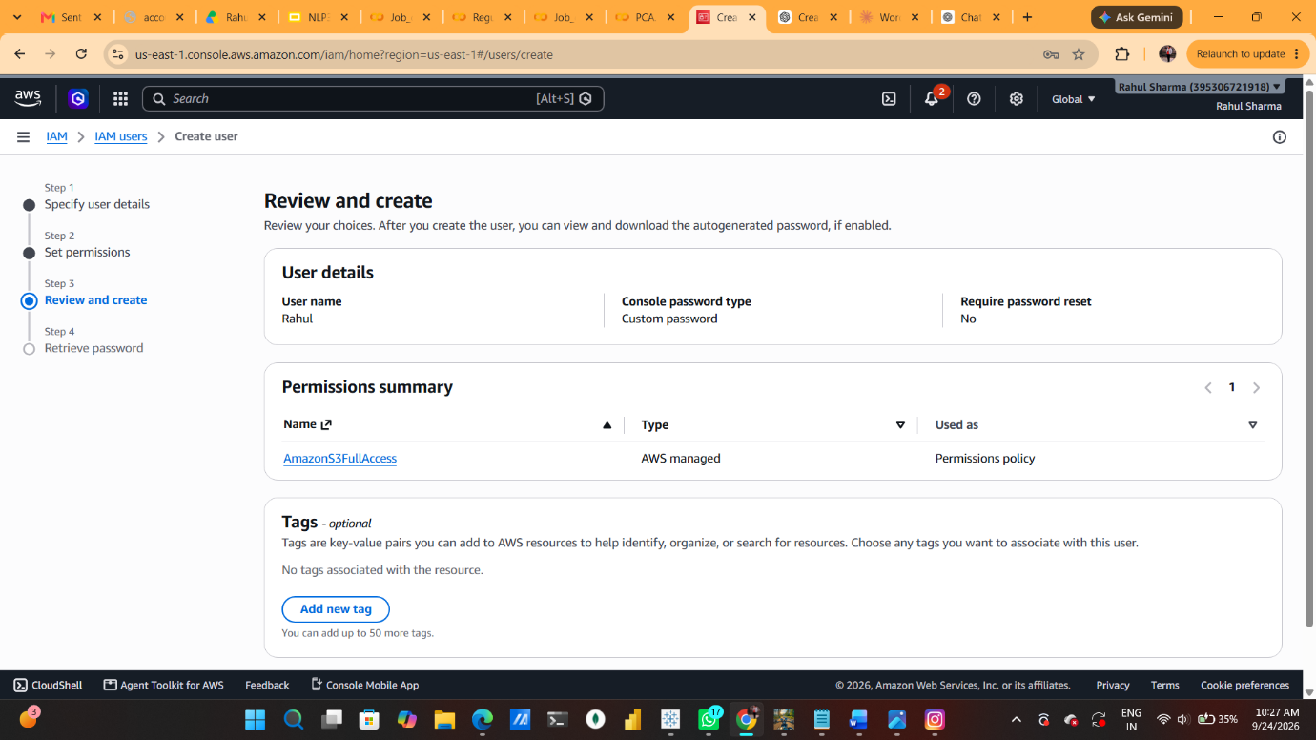

Step 5: User Created — Retrieving the Password
A green banner confirmed "User created successfully." On the Retrieve password screen I could see the one-time details: the console sign-in URL (https://829649333411.signin.aws.amazon.com/console), the user name Rahul, and the console password (masked, with a Show option). I copied the sign-in URL, since AWS warns this is the only time the password is retrievable from this screen.
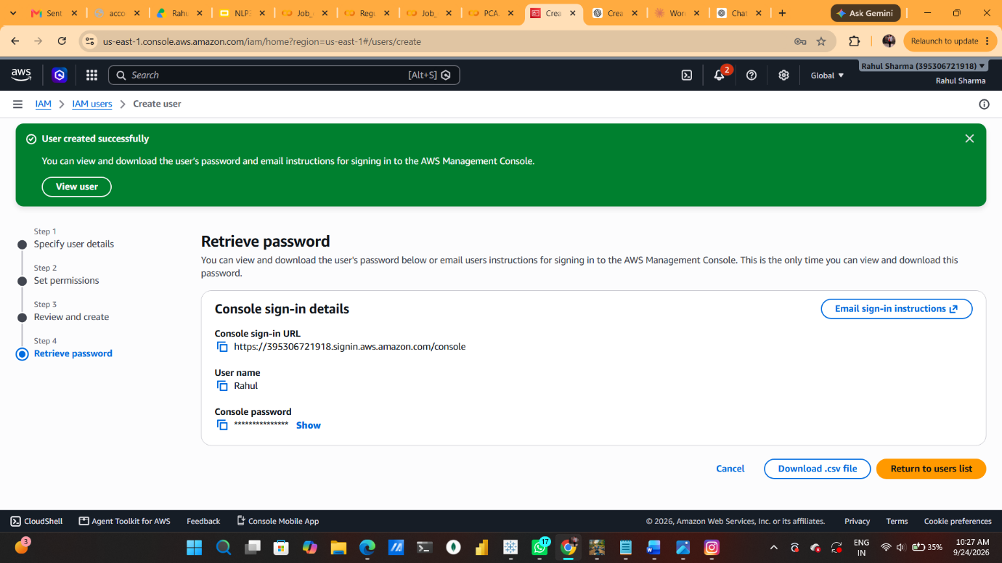

Step 6: Signing In as the New IAM User
Using the copied sign-in URL in a fresh browser tab, I reached the IAM user sign-in page. The Account ID (829649333411) and IAM username (Rahul) were pre-filled, and after entering the password I clicked Sign in to log in as this limited, S3-only user rather than as the root or my main admin account.
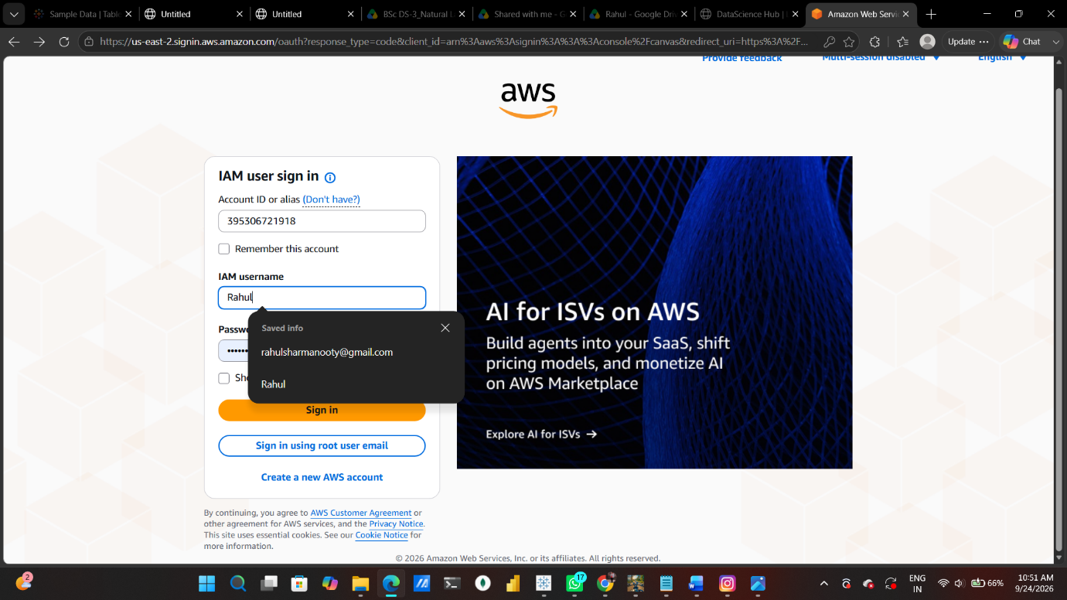

Step 7: Confirming S3 Access as Rahul
Once signed in, I landed on the S3 console in the Europe (Stockholm) region. It showed General purpose buckets (0), meaning the account had no buckets yet, but crucially the page loaded without any permission errors — proof that AmazonS3FullAccess was working exactly as attached.
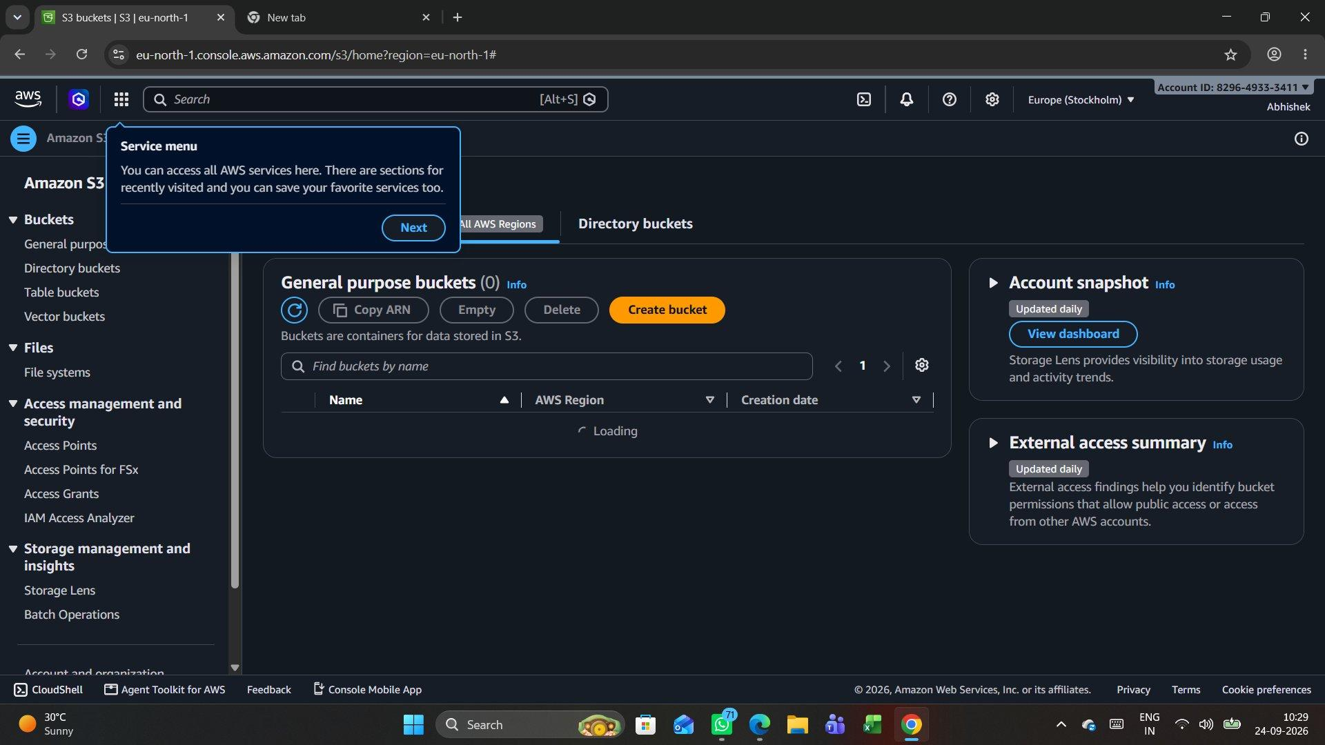

Step 8: Verifying the Permission Boundary on EC2
To check that the policy really was scoped to S3 only, I switched to the EC2 dashboard as the same user. Almost every panel showed "Access denied" — for Auto Scaling Groups, Elastic IPs, Instances, Key pairs, Load balancers, Security groups, Snapshots, Volumes and more, along with an Access denied error under EC2 Free Tier and Service health. This confirmed the least-privilege setup: full S3 access, but no access at all to EC2.
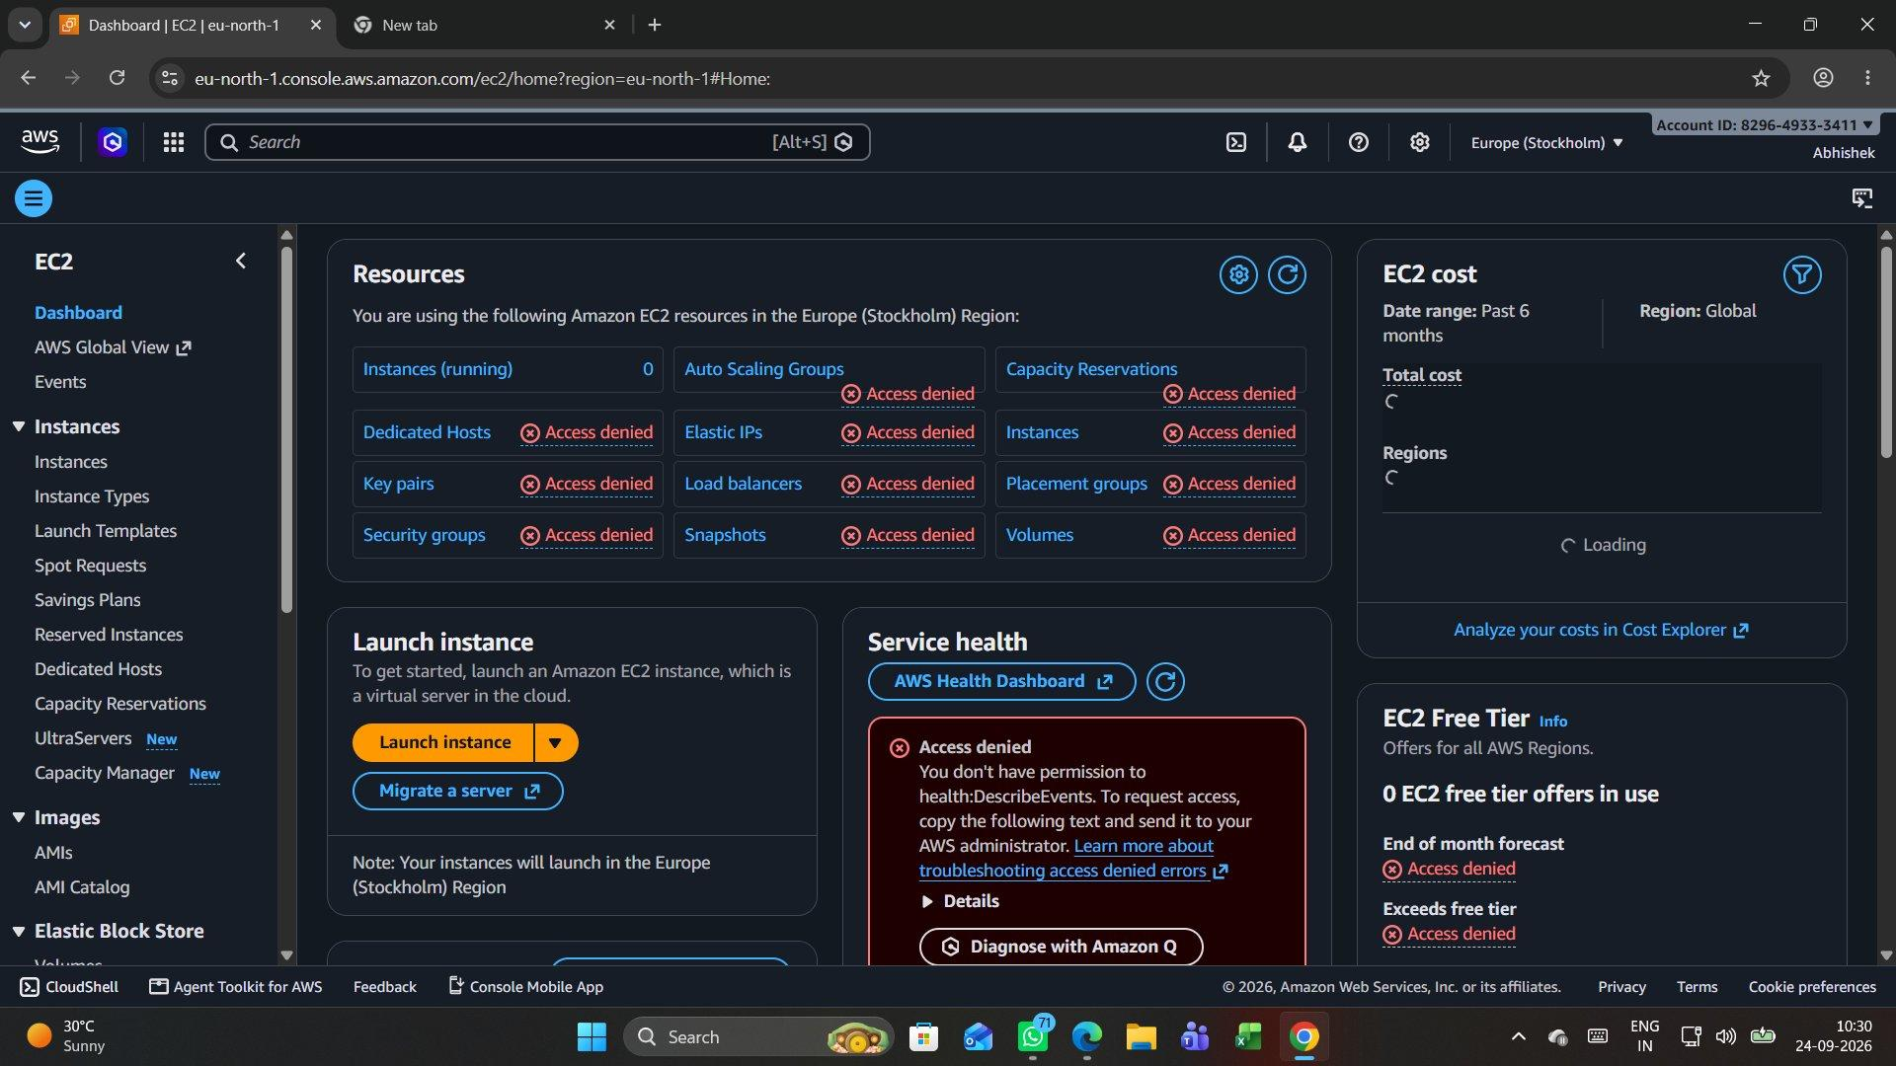

Step 9: Cleaning Up — the IAM User Removed
After confirming the test worked as expected, I went back to the main account and removed the Abhishek user. The IAM users page now read IAM users (0) with "No resources to display", so the account was back to its clean starting state with no leftover test credentials.
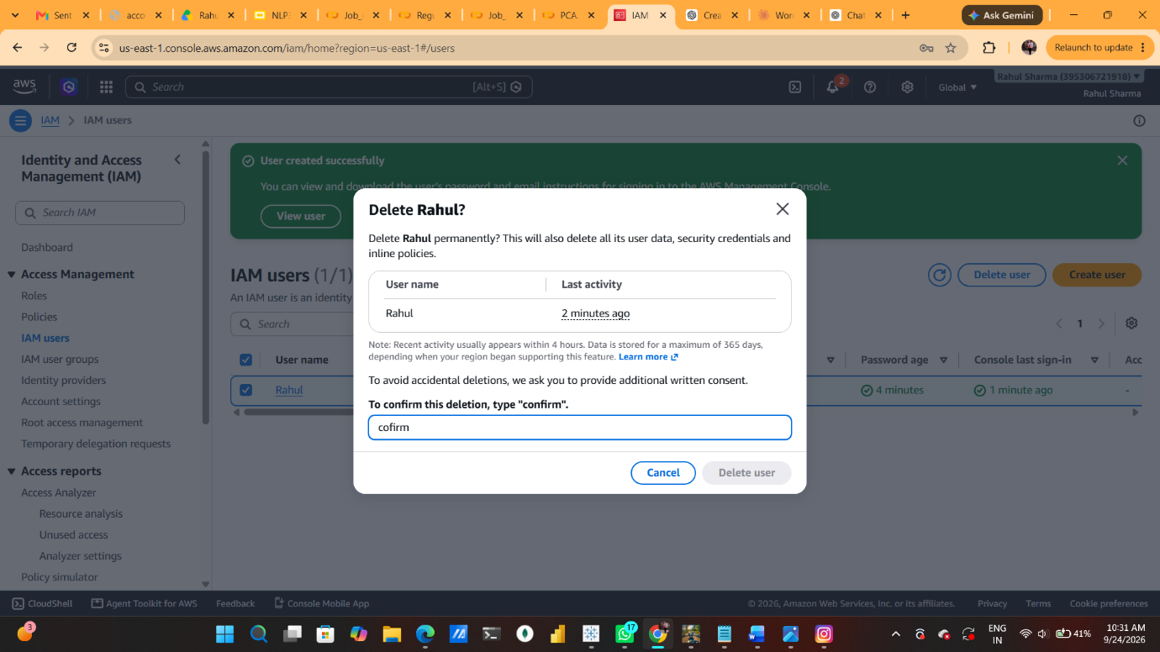

My Full Summary of the Session
The purpose of this exercise was to see least-privilege IAM access work in practice rather than just read about it. I started in IAM > Create user, named the account Rahul, turned on console access, and set a custom password instead of relying on an autogenerated one. I skipped forcing a password reset at next sign-in since this was a short test rather than a real handover to a teammate.
For permissions, I deliberately chose "Attach policies directly" over the group-based best practice, since a single throwaway user did not need a reusable group structure. From the 1,583 available AWS managed policies I attached exactly one: AmazonS3FullAccess. The Review and create screen confirmed the full picture — user name, custom password, no forced reset, and the one S3 policy — before I finalized the user.
Once AWS confirmed "User created successfully," I copied the one-time console sign-in URL from the Retrieve password screen, since that password is not retrievable again afterward. I then opened that URL in a separate tab, signed in as Rahul with the account ID and IAM username pre-filled, and landed on the S3 console with zero permission errors — General purpose buckets (0) loaded cleanly.
To actually prove the boundary rather than assume it, I switched to EC2 as the same signed-in user. Nearly every panel responded with "Access denied" — Auto Scaling Groups, Elastic IPs, Key pairs, Load balancers, Security groups, Snapshots, Volumes, even EC2 Free Tier and Service health data. That contrast was the real payoff of the exercise: one policy gave full, working S3 access while leaving every other service completely locked out, exactly as AmazonS3FullAccess is scoped to do.
Since Rahul was only a test account, I finished by deleting it from the main account. The IAM users list returned to IAM users (0) with "No resources to display," leaving no stray credentials behind. The takeaway I am carrying forward is that attaching a single, narrowly scoped managed policy is an easy and verifiable way to hand someone exactly the access they need — and testing both what works and what is denied is the only way to actually trust that boundary.

